RX Program Summer Intern
Feed. Engage. Strengthen.
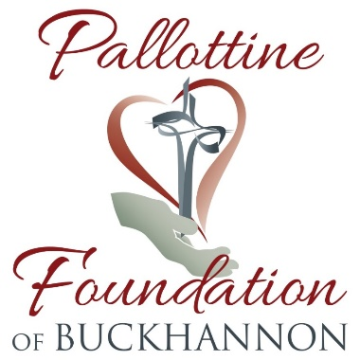
Internship sponsored by:
Imagine a place where your talent can make a meaningful difference in the lives of West Virginia’s veterans. Serving at Mountaineer Food Bank is a uniquely rewarding experience in which our employees and volunteers work together as vital parts of a much larger mission: to feed the hungry in West Virginia. We are innovative, mission-focused, diverse, collaborative, values-driven and focused on results.
We are a West Virginia non-profit and the state's largest feeding organization. Located in the heart of West Virginia, our mission is to feed West Virginia's hungry through a network of feeding programs and engage the state in the fight to end hunger.
Here are examples of what you'll be doing everyday:
The RX Pantry Program Intern will develop the RX Program for Mountaineer Food Bank. The RX Pantry Program aims to provide tailored food boxes and fresh foods to combat chronic diseases; such as cardiovascular, diabetes, and obesity by partnering with FQHC’s and other community healthcare entities to ‘prescribe’ to program participants.
- Develop RX Pantry Program Plan that is effective, easy to implement, and replicable
- Conduct an informal community needs assessment of Upshur County
- Research other health-based feeding programs
- Advise on food products, recipes, and resources packed in the health foodbox
- Make connections with local healthcare providers & clinics
- Schedule meetings with providers to determine best practices for program collaboration
- Create an RX Pantry Program Agreement
- Develop a volunteer plan
- Develop a fundraising plan
- Create a sustainability plan

For your information…
This is an eight week summer internship of 30 hours a week at $12.00/hour. This position would work four day work-weeks at 8 hours/day.
- Internship start date- May 31, 2021
- Internship end date- July 30, 2021
**This date range is nine weeks, extra week included for unpaid vacation time.
RX Intern would report to MFB office location in Flatwoods.
Mountaineer Food Bank values every member of our community and strongly encourages diversity across all of our programming, staffing and volunteers. Our organization strives to support all individuals in need and engage all from every socioeconomic background, culture, ethnicity and race in our fight against hunger. Our staff, board and member network is made up of business leaders, non-profit leaders, community organizers, health professionals, educators and folks from all backgrounds. Our differences bind and strengthen us to make a stronger organization in West Virginia.”
Ready to apply?
Please email your resume and references over to Director of Community Programs, Laura Phillips at laura@mountaineerfoodbank.org. You may also call or direct any questions about this opportunity to Laura by email listed above or by calling 304-364-5518, extension 206. We look forward to talking to you! Interested applicants can submit resumes and references through April 23, 2021.

